Unit 1 - Communication and Employability in IT
Assignment 5 - Task 2 [Part 1]

Introduction

As an established technical professional, you may at times be expected to share and communicate technical information to less technically experienced employees in your company. As such, your ICT Manager has requested that you prepare two technical documents for a non-technical audience. You will need to proof-read, adjust and present the information in a simpler style, whilst still maintaining the appropriate content of the original format.

Original Assignment

Unit 20 – Client Side Customisation of Web Pages
Assignment 1 – HTML and CSS

Introduction
In this assignment I will be covering my understanding of HTML and CSS which is used on the World Wide Web as part of my initial training for the internship at the Web Development company called ‘InsertName’.
Task 1 (P1) - How HTML files access CSS
CSS, or Cascading Style Sheets, is used to apply formatting to a HTML webpage. CSS can be applied in three different ways: inline, internal and external.
Inline Styles
Inline styles are a style of CSS which is implemented to the HTML code using the ‘style’ attribute, this method is acceptable but it’s not the preferred method and it should be avoided because the other methods are much more advantageous than the inline style, especially for management of the document’s style. This is an example of an inline style:
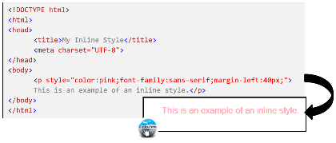
Internal Styles
Internal styles are the second method of applying CSS to the HTML code, it is applied between the opening and closing of <style></style> tags which can be found in the head of the HTML document. This method is a much preferred method than inline style but it’s not commonly used. This style can be used for a HTML document which has a style that is not consistent to the rest of the website.
This is an example of an internal style:
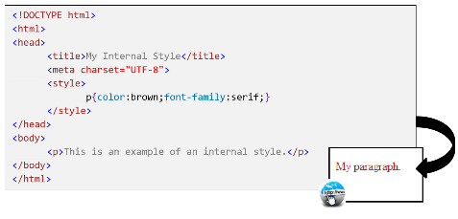
External Styles
External styles are the most common use for CSS and, unlike the other methods, the CSS code is not embedded in the HTML file. This is the most common because it’s the most well run method of CSS, the reason for this is because the style of a whole website can be changed by using just one document. To apply the CSS, the element <link> needs to be places in the head of the HTML document.
This is an example of an external style:
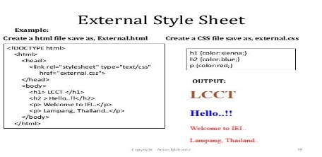
Task 2 (P2) - CSS and the Box model
The box model and its effects on HTML elements is one of the most important parts you should know about CSS. The reason for this is that it makes it a lot easier in creating a professional looking website that you desire. Below are the aspects that produces the foundation and functionality of the box model.
DIV tags
Div tags, or division tags, act like a container that divides the content into sections, div tags are used to combine block-elements so that it can be formatted with CSS, meaning that, after the </div> tag, there is a line feed. Below are examples of div tags in different code configurations.
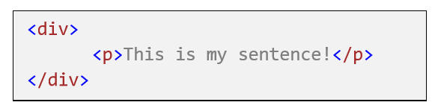HTML
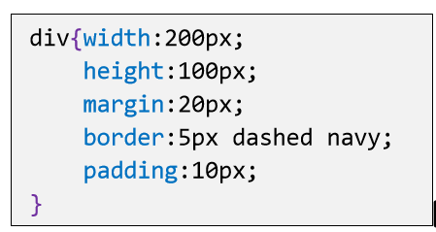CSS
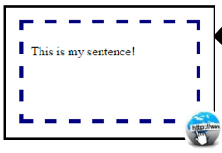Webpage (What the user would see)
Positioning techniques – float, fixed, absolute, static.
For a good website layout design, positioning elements properly is necessary. There are different methods in CSS for methods of positioning. Below are examples of the different positioning techniques. Floats can be used for wrapping text around images or even creating entire web layouts. Floats can also be helpful for smaller instances. For example, float can be used on an avatar image, which would change the size of the text in the box to allow the text to accommodate with the box:
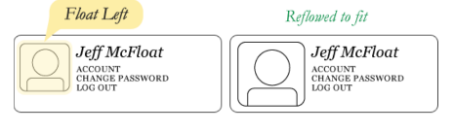
This is one of the scenarios in which floats are more advantageous than other positioning techniques, for example the absolute position would fit the image, but the text wouldn’t be affected:
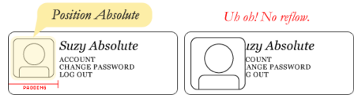
Below are examples of the float in code and website form.
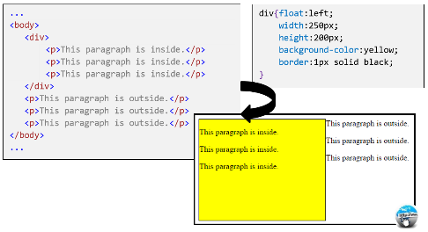
Fixed
Fixed positioning makes the elements fixed to the relative browser window rather than being part of the webpage content, so when the page is being scrolled, the element would stay in the same position in the browser window. Below is an example of a fixed position.
CSS
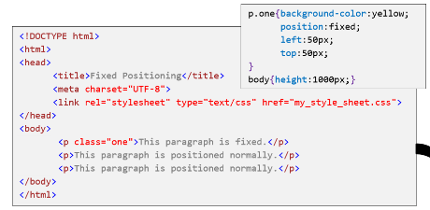
Webpage
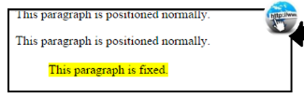
Absolute
When an element is positioned absolutely, it is positioned relative to its first parent or outside the container that has a position. If there isn’t an element, the absolute position is set to the containing <html> block. Absolute positioning overlaps other HTML elements, the reason for this is that an absolute element is removed from the normal flow. Below is an example of what absolute positioning looks like in CSS code and a webpage.
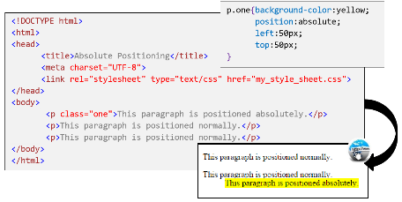
Static
Static positioning is the default positioning for HTML elements and it flows like a normal document. Elements with static positioning cannot use the top, bottom, left and right properties that can be used for other positioning methods. Below is an example of the static positioning, no code is included because it’s the default position configuration for HTML.
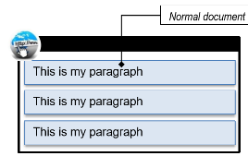
Class and ID selectors
Selectors are a set of rules that is applied to CSS that helps select elements you want to style by using patterns. There are different types of selectors for CSS like Class selectors and ID selectors.
Class selectors
Class selectors are used to define a CSS class that can be applied to many different HTML elements, and they don’t have to be the same type. This is applied to HTML by using the class=”one” attribute. This would apply to elements with the class name ‘one’. Below is an example of a class selector.
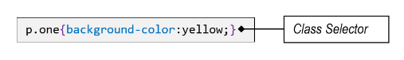
ID selectors
ID selectors are similar to class selectors, but the difference is that ID selectors can only be used once when class can be used multiple times. IDs are often used to identify unique divisions in a web page layout. ID selectors is applied to HTML using the id=”footer” attribute. Below is an example of a code for an ID selector.
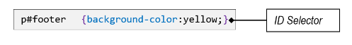
Top, Left and z-index
The top, left and z-index are used to position elements that can overlap other elements. For example, the z-index property specifies which element should be placed in front of, or behind the others. Each element can have a positive or negative stack order. Below is an example of a z-index with a negative order.
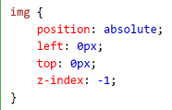
The top and left attributes change which position the element is on the web page, it is measured in pixels. Right and bottom can also be used instead of left or bottom.
Presentation techniques – margin, padding and borders.
Every HTML element is contained within a box and the boxes contain the same properties that enable the appearance of the box to be changed, especially the padding, margin, border and the content within the box. Below is an example of what a box model looks like with its properties.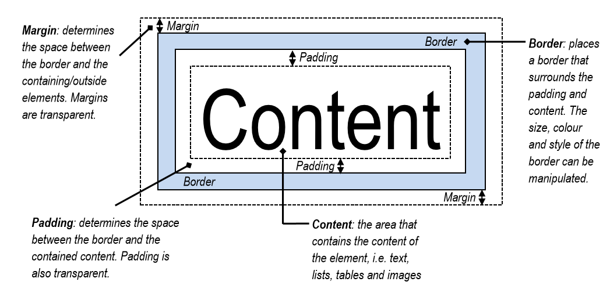
Margin
The margin property creates the space between the border and the containing/outside element, margins cannot be seen by the user, therefore transparent. The margin can be used to space out boxes with their borders away from other, which can make the webpage look less cluttered or neater.
Padding
The padding property creates the space between the border and the contained content. Like the margin property, padding is also transparent. The padding can be used to separate content from the border which also makes the website look cleaner and less cluttered.
Border
The border property places a border that surrounds the padding and content. The size, colour and style of the border can be changed. The border is the only visual part of this presentation technique

Task 3 (M1) - CSS Assessment
In this assessment I will be assessing the three different CSS implementations to see when and where they are best used and what the advantages and disadvantages of each implementation. Below is an assessment of the three different implementations each with details and comparisons about one another.
Inline style
As you learned from the start, the inline style is specific to the HTML tag itself and it uses the <style> attribute to style the specific tag it is in.
This means that the inline stylesheet can only affect one HTML tag at a time. For example, it can be used to cover all the HTML tags but its time wasting because you are repeating the same code over and over, this is why this stylesheet is the most uncommon and even sometimes not recommended to use at all.
The inline style is the highest precedence and will override the lower precedence CSS rules, which would be the rest of the other styles.
The inline style has the “style=” attribute, this attribute is only used within the inline style and cannot be used on the other styles. This attribute is what allows the CSS properties on a “per tag” basis. The following is an example of how the inline style is used.
<p style="color:red;font-size:18px">This is a paragraph!</p>

This inline style would change the colour of the paragraph to red and make the font 18px (pixels).

An example for an inline stylesheet doing a specific job would be it changing the colour of a specific text, as shown in the picture below:
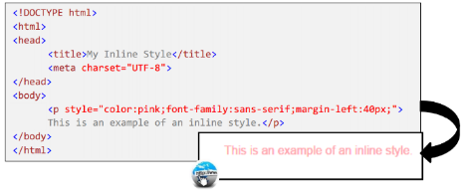
In this example the CSS is changing the font colour to pink on this line of text, this job can be useful for changing the colour of one specific line of text mixed with many others, while keeping the other lines of text the default or different colour to the specific one.

Advantages
Even though inline CSS isn’t recommended by a lot of people, it still has its uses and advantages. For example, inline CSS is great for quick fixes when there’s an error, prototyping an idea for the webpage and being able to do simple tests without going through the trouble of going back and forth between the CSS document and the HTML file.
Inline CSS is also good for email clients because emails don’t allow external CSS referencing because it can interpret it as spam and that inline CSS can be used to override the other styles.
Disadvantages
Of course, inline CSS has its disadvantages. The most obvious one is that it can fill up HTML space, which could make the HTML file very confusing to navigate with the mass amount of CSS and HTML code mixed together.
Another disadvantage of inline CSS is that the code cannot be used across the pages because you cannot reference this type of CSS, which could lead to repeating the code if you want to use it more than once. This would also make it hard to maintain consistency across the related elements.

Internal style
As you also learned from the start, an internal stylesheet is added to the head section of each page. You can use this style when something you want to style just one page out of the whole website. For example, the colour of the font in a highlighted section of the page.
The internal stylesheet sheet can affect all the tags within the HTML document. This is a good method for a small website or a project that only required one HTML document, but anything larger is not recommended because it requires you to repeat yourself, wasting time and increasing unnecessary file size.
The internal style is the 2nd highest precedence and would override the other style and the browser default but would still be overridden by the inline style since the inline style is the highest precedence.
When a stylesheet is created, you will ned to use the <style></style> tags in the head section of the webpage The code of the Internal CSS stylesheet is contained between the <head></head> section of the HTML code. The other styles do not have the <style></style> tags and this is what differentiates this style to the others. Below is an example of what an Internal stylesheet looks like.
<head>
<style type="text/css">
h1 {color:blue;}
h2 {color:red;}
p {color:green;}
</style>
</head>
An example for an internal stylesheet doing one specific job would be changing the colour of the text featured in the whole HTML document, shown in the image below:
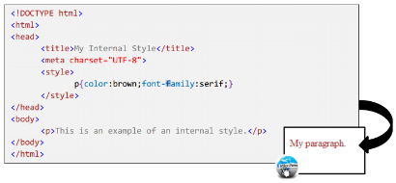
In this example the CSS is changing the font colour of any text that is shown on the HTML document, even though there isn’t much text in this example, it would change the whole thing if there were paragraphs, but this wouldn’t affect any other HTML documents.

Advantages
The advantages of internal CSS (or embedded CSS) is that it is good for quick fixes but it it’s also very good for prototyping ideas to use on a webpage (same as the inline CSS), but it is easier to cut out of the final prototype and put it into an external file when completed.
With internal CSS, the CSS document is embedded on the HTML file so that an additional file wouldn’t need to be created. If there already is an additional CSS file used as an external CSS, the internal CSS could override the external CSS.
Disadvantages
The disadvantages of internal/embedded CSS is that some email clients don’t allow styles in the <head> due to the fact that head-tags are removed by most webmail clients. Also, internal CSS doesn’t allow you to share the styles across the webpages, which means that you would have to copying the text of the internal CSS and pasting it in each page for the website.
With the internal CSS embedded on the HTML file, this could make the code look more cluttered and complex which would make fixing an error or changing the code difficult to do, especially with multiple webpages. This can also make it hard to maintain consistency across the different webpages.

External style
External style sheets are when the CSS code is separate from the HTML code. The best use for this style is when you want your whole webpage to have similarities without needing to repeat code all the time, wasting time and slowing down the download of the webpage.
The external stylesheet can affect all the tags that are within the HTML documents linked with the CSS document. This gives it the ability for one document of CSS code to control multiple HTML documents. This is why this is the most commonly used one, because of its efficiency and reduced file size compared to the other two.
External style is the lower precedence out of the other CSS rules but would still override the browser default, so if there are other CSS rules on the HTML document, it would override the external style.
What differentiates external styles from the others is that it uses the <link> tag in the HTML document. This is used to link the CSS with the HTML documents, as mentioned before, it gives it the ability to be used on many HTML documents. Below is an example of what the <link> tag would look like inside the <head> tag in a HTML document.
<head>
css” href=”mystyle.css” />
</head>

An example of an external stylesheet doing a specific job would be changing the size of the font size of the header and the font size of the paragraphs, as shown below:
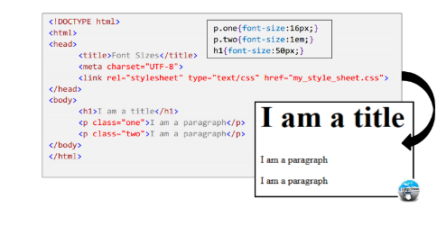
In this example the external CSS increased the size of the header to 50px and also changed the size of the paragraph text to 16px and 1em, which is the same size, as shown in the example. This can be used on multiple HTML documents but only if the correct CSS document was linked in the HTML head.

Advantages
The reason external CSS is used more by others is due to the advantages of using external CSS. The advantages are that external CSS is easy to maintain because the CSS code is only on one CSS document which can be reused across a website with more than 1 page. External CSS is also cacheable which means there is less bandwidth, what I mean by this is that the page will load faster after you visit the page for a second time.
With external CSS, you can remove all the unused space from the final build. For example, the jQuery software has some sort of developer version and a compressed version which means that you have a faster download which would give faster user experience and less bandwidth use, which equals faster internet.
Disadvantages
External CSS may be the most used style, but also has its disadvantages. The disadvantages of external CSS is that it could make an extra HTTP request per file, this means that more resources have to be used in the routers and even the firewalls.
Another disadvantage is that if there is an error on the code or you want to make a change, it could become unmanageable and difficult to edit complex layouts. With external CSS you also need to use consistent markup on multiple pages, which may not seem like a complex problem but a small mistake can cause big problems.

Improved Assignment

Unit 20 – Client Side Customisation of Web Pages
Assignment 1 – HTML and CSS

Introduction
In this assignment I will be covering my understanding of HTML and CSS which is used on the World Wide Web as part of my initial training for the internship at the Web Development company called ‘InsertName’.

Task 1 (P1) - How HTML files access CSS
CSS, or Cascading Style Sheets, is used to apply formatting to a HTML webpage. CSS can be applied in three different ways: inline, internal and external.
Inline Styles
Inline styles are a style of CSS which is implemented to the HTML code using the ‘style’ attribute, this method is acceptable but it’s not the preferred method and it should be avoided because the other methods are much more advantageous than the inline style, especially for management of the document’s style.
This is an example of an inline style:
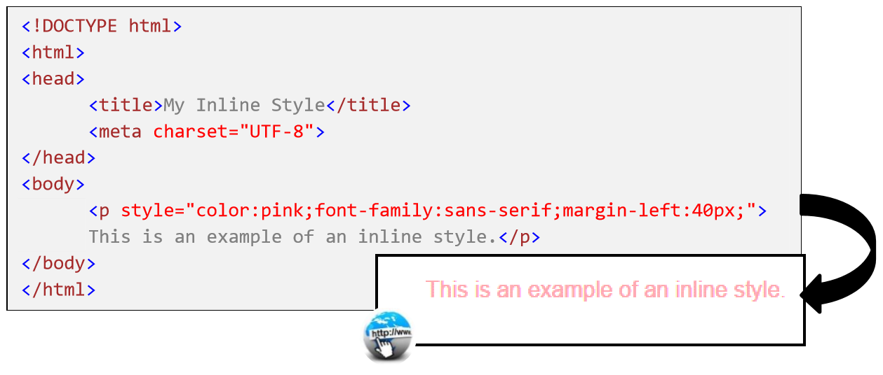
Internal Styles
Internal styles are the second method of applying CSS to the HTML code, it is applied between the opening and closing of <style></style> tags which can be found in the head of the HTML document. This method is a much preferred method than inline style but it’s not commonly used. This style can be used for a HTML document which has a style that is not consistent to the rest of the website.
This is an example of an internal style:
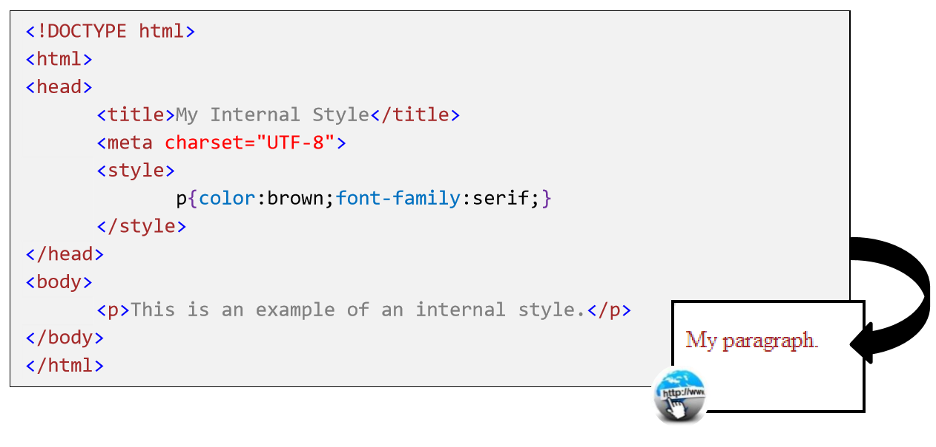
External Styles
External styles are the most common use for CSS and, unlike the other methods, the CSS code is not embedded in the HTML file. This is the most common because it’s the most efficient method of CSS, the reason for this is because the style of a whole website can be changed by using just one document. To apply the CSS, the element <link> needs to be places in the head of the HTML document.
This is an example of an external style:
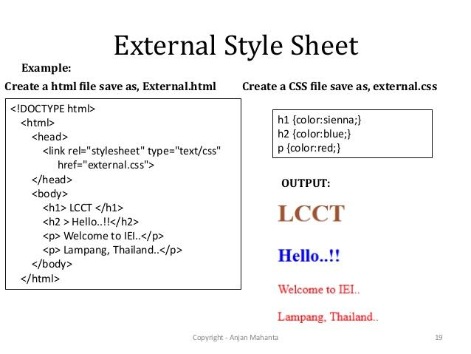
Task 2 (P2) - CSS and the Box model
The box model and its effects on HTML elements is one of the most important parts you should know about CSS. The reason for this is that it makes it a lot easier in creating a professional looking website that you desire. Below are the aspects that produces the foundation and functionality of the box model.
DIV tags
Div tags, or division tags, act like a container that divides the content into sections, div tags are used to combine block-elements so that it can be formatted with CSS, meaning that, after the </div> tag, there is a line feed. Below are examples of div tags in different code configurations.

HTML
CSS

Webpage (What the user would see)
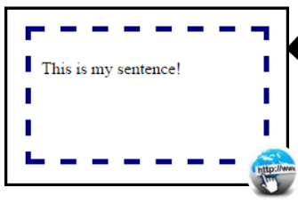
Positioning techniques – float, fixed, absolute, static.
For a good website layout design, positioning elements properly is necessary. There are different methods in CSS for methods of positioning. Below are examples of the different positioning techniques.

Float
Floats can be used for wrapping text around images or even creating entire web layouts. Floats can also be helpful for smaller instances. For example, float can be used on an avatar image, which would change the size of the text in the box to allow the text to accommodate with the box:
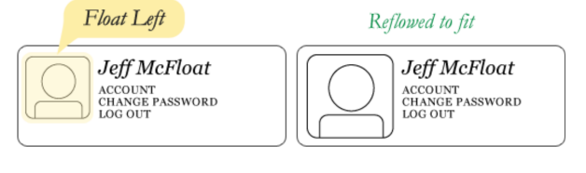
This is one of the scenarios in which floats are more advantageous than other positioning techniques, for example the absolute position would fit the image, but the text wouldn’t be affected:
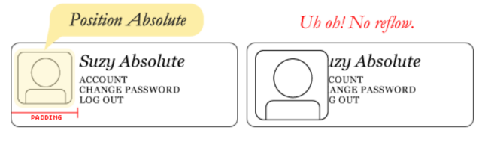
Below are examples of the float in code and website form.

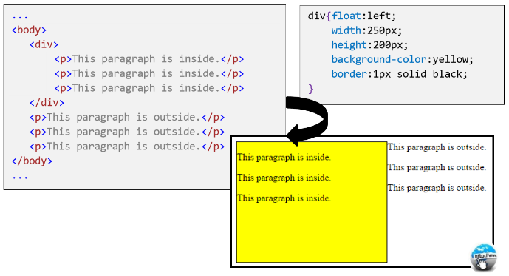

Fixed
Fixed positioning makes the elements fixed to the relative browser window rather than being part of the webpage content, so when the page is being scrolled, the element would stay in the same position in the browser window. Below is an example of a fixed position.
CSS
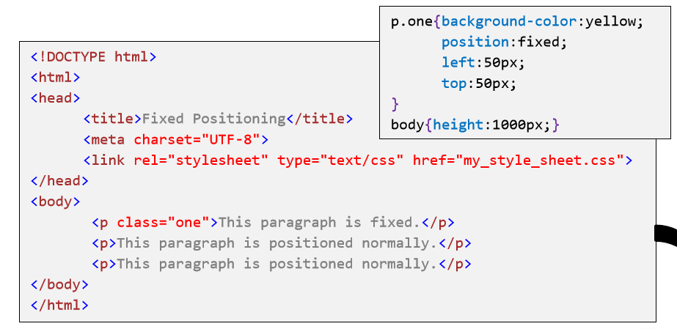
Webpage
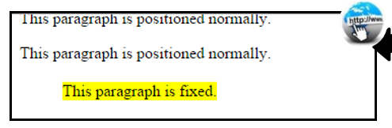

Absolute
When an element is positioned absolutely, it is positioned relative to its first parent or outside the container that has a position. If there isn’t an element, the absolute position is set to the containing <html> block. Absolute positioning overlaps other HTML elements, the reason for this is that an absolute element is removed from the normal flow. Below is an example of what absolute positioning looks like in CSS code and a web page.
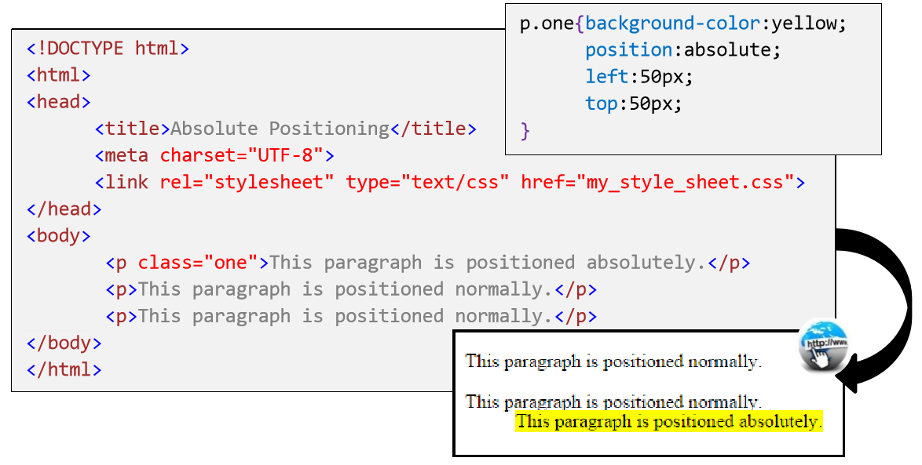

Static
Static positioning is the default positioning for HTML elements and it flows like a normal document. Elements with static positioning cannot use the top, bottom, left and right properties that can be used for other positioning methods. Below is an example of the static positioning, no code is included because it’s the default position configuration for HTML.
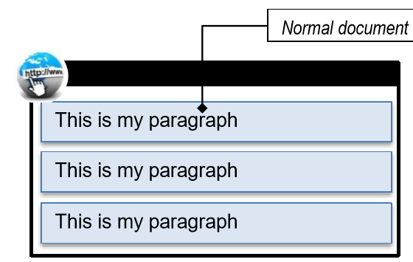

Class and ID selectors
Selectors are a set of rules that is applied to CSS that helps select elements you want to style by using patterns. There are different types of selectors for CSS like Class selectors and ID selectors.
Class selectors
Class selectors are used to define a CSS class that can be applied to many different HTML elements, and they don’t have to be the same type. This is applied to HTML by using the class=”one” attribute. This would apply to elements with the class name ‘one’. Below is an example of a class selector.
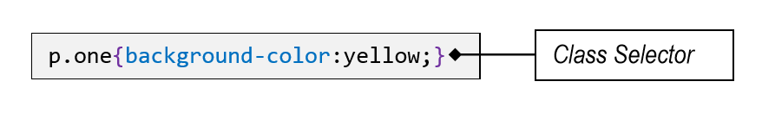
ID selectors
ID selectors are similar to class selectors, but the difference is that ID selectors can only be used once when class can be used multiple times. IDs are often used to identify unique divisions in a web page layout. ID selectors is applied to HTML using the id=”footer” attribute. Below is an example of a code for an ID selector.
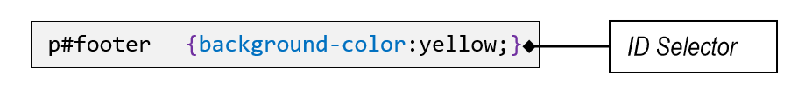

Top, Left and z-index
The top, left and z-index are used to position elements that can overlap other elements. For example, the z-index property specifies which element should be placed in front of, or behind the others. Each element can have a positive or negative stack order. Below is an example of a z-index with a negative order.
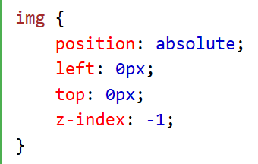
The top and left attributes change which position the element is on the web page, it is measured in pixels. Right and bottom can also be used instead of left or bottom.
Presentation techniques – margin, padding and borders.
Every HTML element is contained within a box and the boxes contain the same properties that enable the appearance of the box to be changed, especially the padding, margin, border and the content within the box. Below is an example of what a box model looks like with its properties.
Margin
The margin property creates the space between the border and the containing/outside element, margins cannot be seen by the user, therefore transparent. The margin can be used to space out boxes with their borders away from other, which can make the web page look less cluttered or neater.
Padding
The padding property creates the space between the border and the contained content. Like the margin property, padding is also transparent. The padding can be used to separate content from the border which also makes the website look cleaner and less cluttered.
Border
The border property places a border that surrounds the padding and content. The size, colour and style of the border can be changed. The border is the only visual part of this presentation technique

Task 3 (M1) - CSS Assessment
In this assessment I will be assessing the three different CSS implementations to see when and where they are best used and what the advantages and disadvantages of each implementation. Below is an assessment of the three different implementations each with details and comparisons about one another.
Inline style
As you learned from the start, the inline style is specific to the HTML tag itself and it uses the <style> attribute to style the specific tag it is in.
This means that the inline stylesheet can only affect one HTML tag at a time. For example, it can be used to cover all the HTML tags but its time wasting because you are repeating the same code over and over, this is why this stylesheet is the most uncommon and even sometimes not recommended to use at all.
The inline style is the highest precedence and will override the lower precedence CSS rules, which would be the rest of the other styles.
The inline style has the “style=” attribute, this attribute is only used within the inline style and cannot be used on the other styles. This attribute is what allows the CSS properties on a “per tag” basis. The following is an example of how the inline style is used.
<p style="color:red;font-size:18px">This is a paragraph!</p>

This inline style would change the colour of the paragraph to red and make the font 18px (pixels).

An example for an inline stylesheet doing a specific job would be it changing the colour of a specific text, as shown in the picture below:
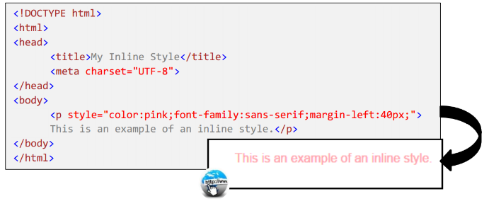
In this example the CSS is changing the font colour to pink on this line of text, this job can be useful for changing the colour of one specific line of text mixed with many others, while keeping the other lines of text the default or different colour to the specific one.

Advantages
Even though inline CSS isn’t recommended by a lot of people, it still has its uses and advantages. For example, inline CSS is great for quick fixes when there’s an error, prototyping an idea for the webpage and being able to do simple tests without going through the trouble of going back and forth between the CSS document and the HTML file.
Inline CSS is also good for email clients because emails don’t allow external CSS referencing because it can interpret it as spam and that inline CSS can be used to override the other styles.
Disadvantages
Of course, inline CSS has its disadvantages. The most obvious one is that it can fill up HTML space, which could make the HTML file very confusing to navigate with the mass amount of CSS and HTML code mixed together.
Another disadvantage of inline CSS is that the code cannot be used across the pages because you cannot reference this type of CSS, which could lead to repeating the code if you want to use it more than once. This would also make it hard to maintain consistency across the related elements.

Internal style
As you also learned from the start, an internal stylesheet is added to the head section of each page. You can use this style when something you want to style just one page out of the whole website. For example, the colour of the font in a highlighted section of the page.
The internal style sheets sheet can affect all the tags within the HTML document. This is a good method for a small website or a project that only required one HTML document, but anything larger is not recommended because it requires you to repeat yourself, wasting time and increasing unnecessary file size.
The internal style is the 2nd highest precedence and would override the other style and the browser default but would still be overridden by the inline style since the inline style is the highest precedence.
When a stylesheet is created, you will need to use the <style></style> tags in the head section of the webpage The code of the Internal CSS stylesheet is contained between the <head></head> section of the HTML code. The other styles do not have the <style></style> tags and this is what differentiates this style to the others. Below is an example of what an Internal stylesheet looks like.
<head>
<style type="text/css">
h1 {color:blue;}
h2 {color:red;}
p {color:green;}
</style>
</head>

An example for an internal stylesheet doing one specific job would be changing the colour of the text featured in the whole HTML document, shown in the image below:
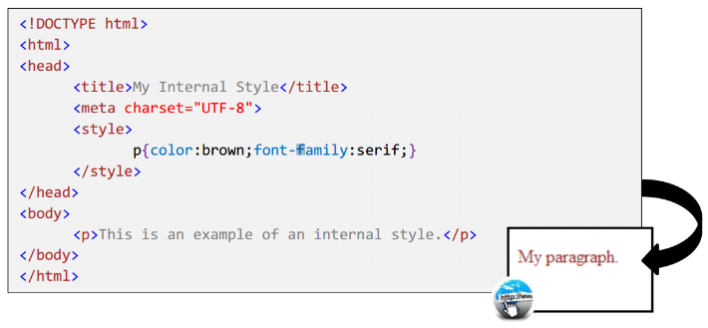
In this example the CSS is changing the font colour of any text that is shown on the HTML document, even though there isn’t much text in this example, it would change the whole thing if there were paragraphs, but this wouldn’t affect any other HTML documents.

Advantages
The advantages of internal CSS (or embedded CSS) is that it is good for quick fixes but it it’s also very good for prototyping ideas to use on a web page (same as the inline CSS), but it is easier to cut out of the final prototype and put it into an external file when completed.
With internal CSS, the CSS document is embedded on the HTML file so that an additional file wouldn’t need to be created. If there already is an additional CSS file used as an external CSS, the internal CSS could override the external CSS.
Disadvantages
The disadvantages of internal/embedded CSS is that some email clients don’t allow styles in the <head> due to the fact that head-tags are removed by most webmail clients. Also, internal CSS doesn’t allow you to share the styles across the web pages, which means that you would have to copying the text of the internal CSS and pasting it in each page for the website.
With the internal CSS embedded on the HTML file, this could make the code look more cluttered and complex which would make fixing an error or changing the code difficult to do, especially with multiple web pages. This can also make it hard to maintain consistency across the different webpages.
External style
External style sheets are when the CSS code is separate from the HTML code. The best use for this style is when you want your whole webpage to have similarities without needing to repeat code all the time, wasting time and slowing down the download of the webpage.
The external stylesheet can affect all the tags that are within the HTML documents linked with the CSS document. This gives it the ability for one document of CSS code to control multiple HTML documents. This is why this is the most commonly used one, because of its efficiency and reduced file size compared to the other two.
External style is the lower precedence out of the other CSS rules but would still override the browser default, so if there are other CSS rules on the HTML document, it would override the external style.
What differentiates external styles from the others is that it uses the <link> tag in the HTML document. This is used to link the CSS with the HTML documents, as mentioned before, it gives it the ability to be used on many HTML documents. Below is an example of what the <link> tag would look like inside the <head> tag in a HTML document.
<head>
css” href=”mystyle.css” />
</head>

An example of an external stylesheet doing a specific job would be changing the size of the font size of the header and the font size of the paragraphs, as shown below:
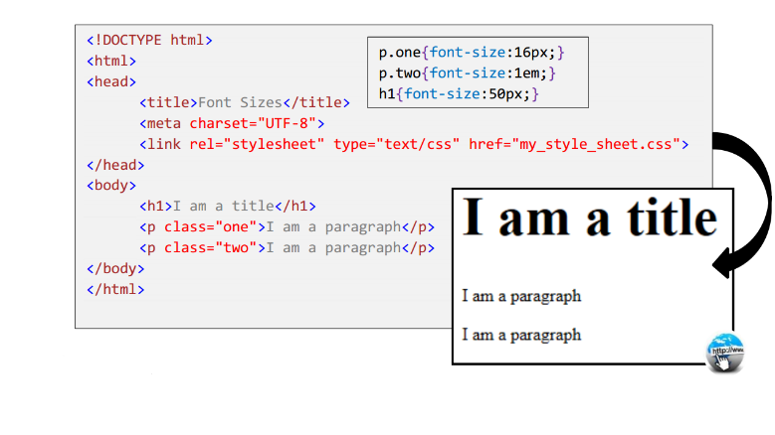
In this example the external CSS increased the size of the header to 50px and also changed the size of the paragraph text to 16px and 1em, which is the same size, as shown in the example. This can be used on multiple HTML documents but only if the correct CSS document was linked in the HTML head.

Advantages
The reason external CSS is used more by others is due to the advantages of using external CSS. The advantages are that external CSS is easy to maintain because the CSS code is only on one CSS document which can be reused across a website with more than 1 page. External CSS is also cacheable which means there is less bandwidth, what I mean by this is that the page will load faster after you visit the page for a second time.
With external CSS, you can remove all the unused space from the final build. For example, the jQuery software has some sort of developer version and a compressed version which means that you have a faster download which would give faster user experience and less bandwidth use, which equals faster internet.
Disadvantages
External CSS may be the most used style, but also has its disadvantages. The disadvantages of external CSS is that it could make an extra HTTP request per file, this means that more resources have to be used in the routers and even the firewalls.
Another disadvantage is that if there is an error on the code or you want to make a change, it could become unmanageable and difficult to edit complex layouts. With external CSS you also need to use consistent markup on multiple pages, which may not seem like a complex problem but a small mistake can cause big problems.

